**COMSATS University Islamabad, Lahore Campus**



**DEPARTMENT OF MANAGEMENT SCIENCES**

**Course Title:**

Programming Language for Business Analytics

**Submitted To:**

Ma’am Sameet Fatima

**Submission By:**

Azan Ali (Fa24-BBA-066)

**Topic:**

Class Activity:2

**Task 1:**

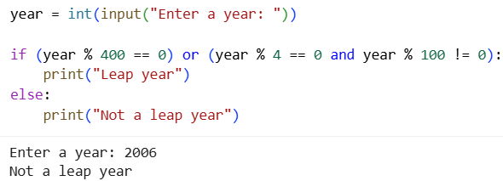

**Task 2:**

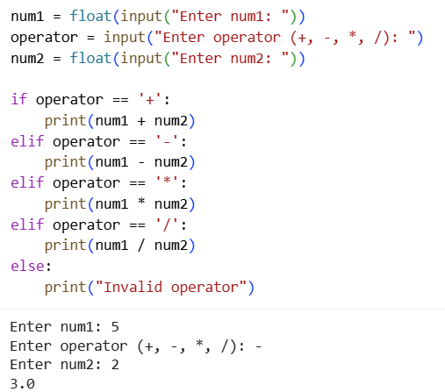

**Task 3:**

